**Recommendations for Big Mountain Resort**

* Using given dataset, we have built a model that predicts ideal Ticket Price and there by the Revenue, assuming 350000 visitors on an average and each skiing 5 days at the Big Mountain Resort, based on the facilities offered by the Resort.
* It has been identified that Big Mountain Resort is currently undercharging and there is room for increasing the Ticket Price to up to $95.87 with the current facilities.

**Recommendations for short-listed business initiatives:**

* **Scenario 1:** Permanently closing down up to 10 of the least used runs.

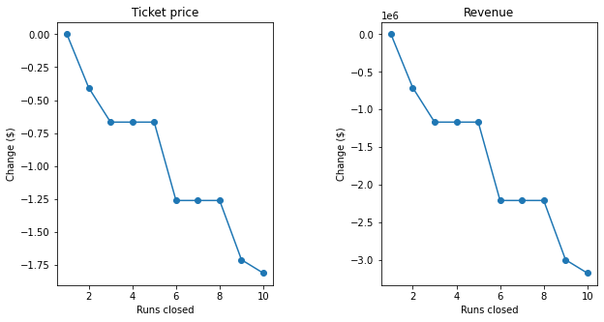

**Recommendation:** Plotting change in Price & Revenue by Number of Runs Closed, it can be seen that closing one run makes no difference, while closing 2 and 3 successively reduces support for ticket price and there by the revenue. Closing 3 or 4 or 5 runs has equal impact on the price while closing any more than 6 runs significantly drops the price.

* **Scenario 2:** Increase the vertical drop by adding a run to a point 150 feet lower down but requiring the installation of an additional chair lift to bring skiers back up, without additional snow making coverage.

**Recommendation:** Increasing vertical drop by 150 feet and installing an additional chair lift can support increase in ticket price by $1.99 and revenue by $3474638.

* **Scenario 3:** Same as Scenario 2 but adding 2 acres of snow making cover.

**Recommendation:** By adding 2 acres of snow making cover to Scenario 2 is not significant and increase in ticket price and revenue would be same as Scenario 2.

* **Scenario 4:** Increase the longest run by 0.2 mile to boast 3.5 miles length, requiring an additional snow making coverage of 4 acres.

**Recommendation:** Increasing longest run by 0.2 miles and adding 4 acres of snow making capability has no impact on ticket price and revenue.